M.vennela
2303A51112
Batch - 03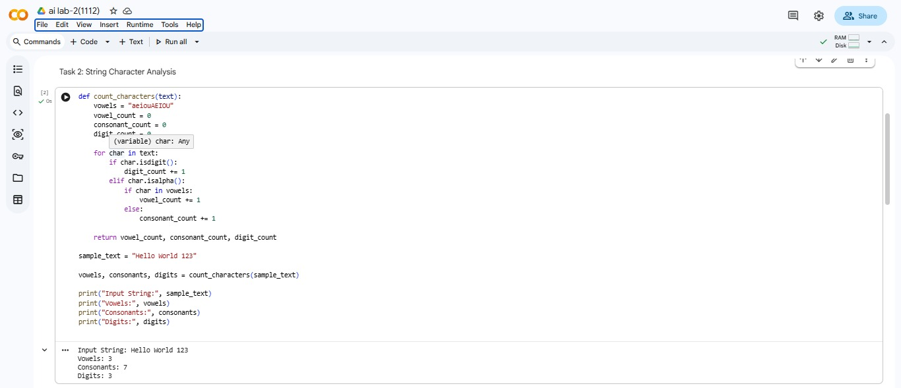

Lab 2: Exploring Additional AI Coding Tools beyond Copilot – Gemini (Colab)
and Cursor AI

Task 1:
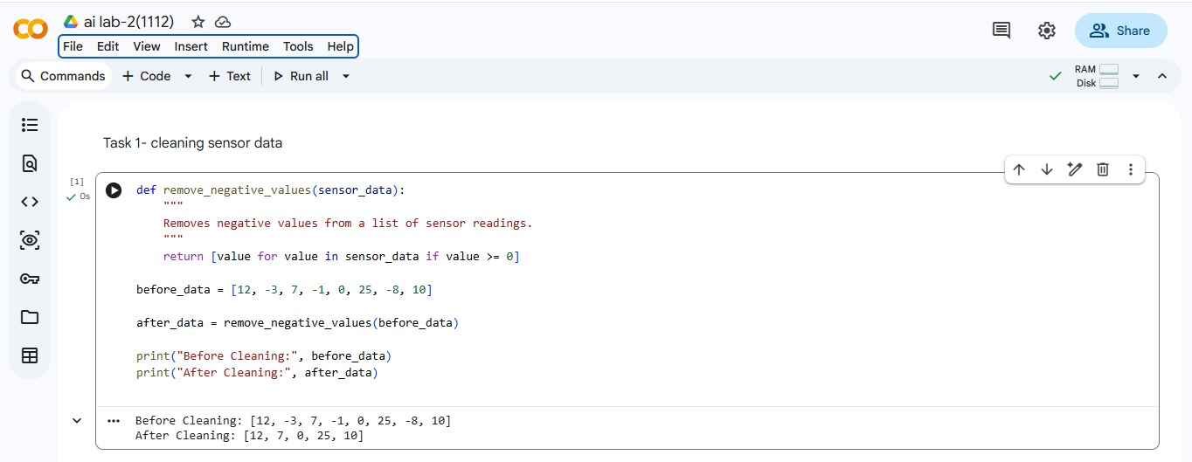
Cleaning Sensor Data – Observation:
The function successfully removes all negative values from the sensor data.
Gemini generated clean and efficient code using list comprehension.
The output clearly shows the data before and after cleaning.
This method is suitable for real-world IoT data preprocessing.

Task 2:
String Character Analysis – Observation:
The function correctly counts vowels, consonants, and digits in the string.
Gemini used built-in string methods, making the logic easy to understand.
The code works for different types of input strings.
The output is accurate and well-structured.

Task 3:
Palindrome Check – Tool Comparison Observation:
Gemini’s code is simple and beginner-friendly.
GitHub Copilot’s code is more robust and handles special characters.
Both implementations correctly identify palindromes.
Copilot’s solution is better for real-world applications, while Gemini’s is easier to learn.
Task 4:
Code Explanation Using AI – Observation:
Gemini explained the code clearly in a line-by-line manner.
The explanation helped in understanding the logic and flow of the function.
The use of square root optimization was clearly explained.
This improved confidence in reading and understanding unfamiliar code.

